**Project Design Phase-II**

**Data Flow Diagram & User Stories**

|  |  |
| --- | --- |
| Date | 03 October 2022 |
| Team ID | PNT2022TMID04781 |
| Project Name | SmartFarmer - IoT Enabled Smart Farming Application |
| Maximum Marks | 4 Marks |

**Data Flow Diagrams:**

A Data Flow Diagram (DFD) is a traditional visual representation of the information flows within a system. A neat and clear DFD can depict the right amount of the system requirement graphically. It shows how data enters and leaves the system, what changes the information, and where data is stored.



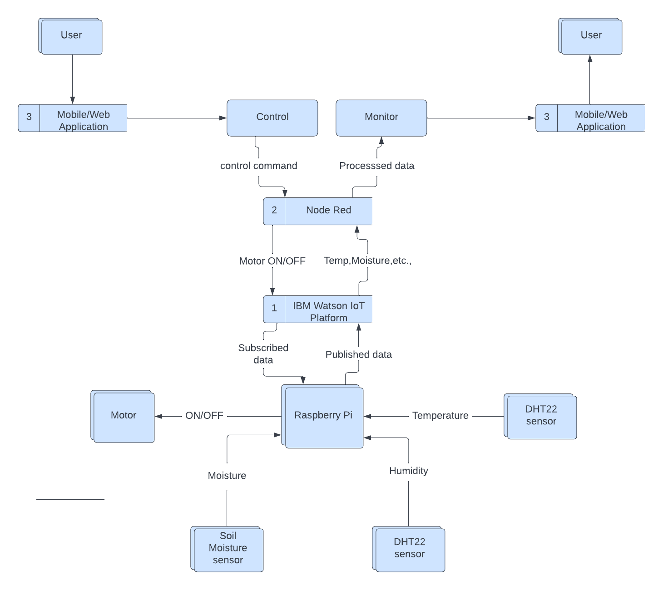

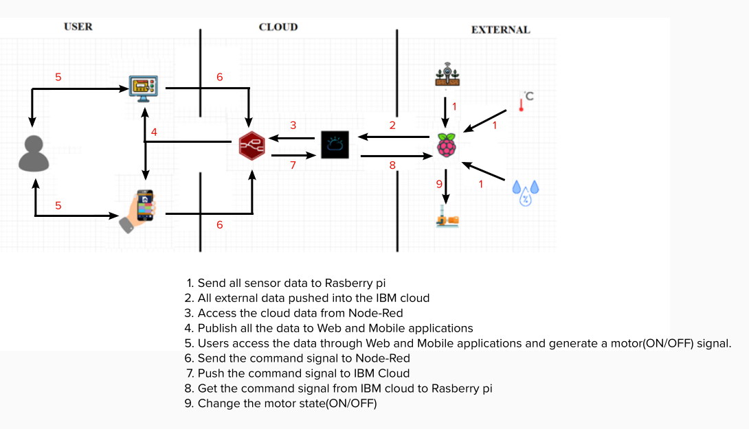

**User Stories**

Use the below template to list all the user stories for the product.

| **User Type** | **Functional Requirement (Epic)** | **User Story Number** | **User Story / Task** | **Acceptance criteria** | **Priority** | **Release** |
| --- | --- | --- | --- | --- | --- | --- |
| Customer (Mobile user) | Dashboard | USN-1 | As a user I can see the Temperature, Humidity and Moisture level | I can monitor those things in dashboard | High | Sprint-1 |
|  |  | USN-2 | As a user I can able to control the motor in this | I can use the controls on/oiff | High | Sprint-2 |
|  |  | USN-3 | As a user I can able to change control mode auto/manual | I can use the option to change the mode | Low | Sprint-2 |
| Customer (Web user) | Dashboard | USN-1 | As a user I can see the Temperature, Humidity and Moisture level | I can monitor those things in dashboard | High | Sprint-3 |
|  |  | USN-2 | As a user I can able to control the motor in this | I can use the controls on/oiff | High | Sprint-3 |
|  |  | USN-3 | As a user I can able to change control mode auto/manual | I can use the option to change the mode | Low | Sprint-4 |